The Financial Times
“The Big Read” published in the paper on June 23, 2016

Latin America:Under new management
John Paul Rathbone
The region is rejecting populism even as the US and Europe flirt with it
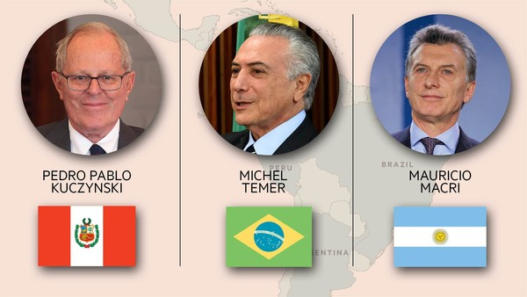
Gabriela Michetti, who is confined to a wheelchair after a car accident two decades ago, does not easily succumb to despair. Yet last December, when Argentina’s new vice-president first moved into Buenos Aires’ belle époque Senate building, she burst into tears.
“Everything was a mess. I discovered there had been no public contract tenders for years. Often there were no records at all. I started crying,” says the 51-year old. “The waste of taxpayer’s money was flagrant. The internet service we now use is seven times cheaper. With the savings, we can repair the building; it had become decrepit.”
Ms Michetti’s tale of private dismay over public waste is a parable of the region. All of a sudden, much of Latin America has come under new management. Even as the US and Europe flirt with populism, a near continent-wide romance with the leftist leaders that rose to power in the 2000s has given way to “populism fatigue”, rage over state-sanctioned corruption and a swing to the political centre.
At the same time, an economic slowdown — regional output is forecast to shrink for a second year running for the first time since the “lost decade” of the 1980s — has forced a return to orthodoxy.
“Many of the populist leaders elected in the late 1990s and early 2000s . . . had the fortune of coming to power in the midst of a global commodity boom that supported their profligate projects and popularity,” says Chris Sabatini, adjunct professor of international relations at Columbia University. “With the collapse of global commodity prices that era is ending, taking with it many of these leaders.”
Argentina last year elected Mauricio Macri, a centrist, as president, after 12 years of populist rule by Cristina Fernández and her late husband, Néstor Kirchner. Mr Macri has made “governance” a rallying cry and launched an economic reform programme.
Meanwhile, Brazil’s controversial impeachment process has seen Dilma Rousseff replaced as president by Michel Temer while she faces trial. As in Argentina, Mr Temer wants sensible economic policymaking to be his government’s hallmark, and has made high-calibre appointments to the finance ministry, central bank, state-controlled energy company Petrobras and national development bank BNDES.
Although Mr Temer has lost three ministers to corruption allegations in seven weeks, the interim president says that Brazil, suffering its worst recession in a century, will be “saved” if his administration’s sole legacy is that the country sticks with his economic team.
“One corrupt group of politicians may have replaced another, but at least this group is barking up the right trees,” says a Brazilian captain of industry of Mr Temer’s administration.
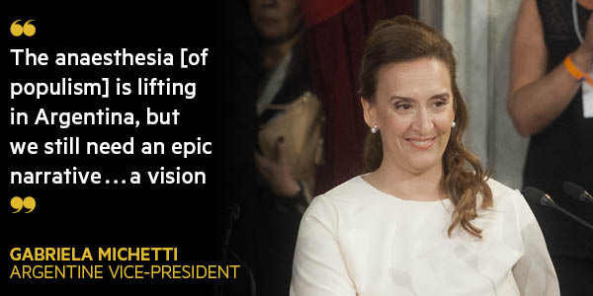
Nor are voters only rejecting the populist left. Peruvians this month elected Pedro Pablo Kuczynski, an economist, as their new president, over rightwing populist Keiko Fujimori, the daughter of a disgraced and imprisoned former president. Notable for a continent renowned for political polarisation, Mr Kuczynski won in large part thanks to support from the Peruvian left.
Compounding the sense of a long ideological cycle ending is Cuba’s rapprochement with the US after more than half a century of mutual hostility, and continuing peace talks between the Colombian government and the Revolutionary Armed Forces of Colombia (Farc), the hemisphere’s oldest guerrilla insurgency.
“The symbols of the traditional cold war left are coming to an end,” says Mr Sabatini.

‘A sudden knockout punch’
The sense of regional change is both profound and fast: the shift has taken place in barely six months. Two factors have sped it along.
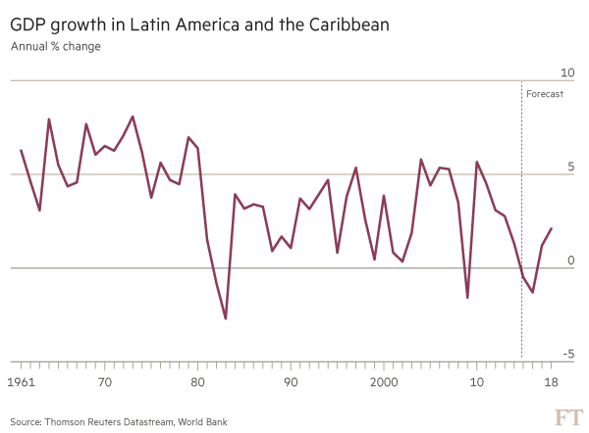
First, there is the dire example of socialist Venezuela — the mirror that the region looks into and is horrified by what it sees. Amid galloping inflation and food riots, maladministration has reached such heights that the finance commission of the opposition-controlled National Assembly estimates that 17 years of chavismo — the name given to the politics of former president Hugo Chávez — have seen more than $425bn of public money stolen or wasted.
“One reason why we won [last year’s] election is that many saw what was happening in Venezuela and worried it could happen here,” says Ms Michetti. A similar dynamic played out in Brazil, when street protesters marching against Ms Rousseff’s government demanded “More Argentina, less Venezuela”.
The spectre of Venezuelan-style populism has even been deployed in Spain’s elections to discredit Podemos, a leftist party with links to Caracas. “If they want to bring that model here, they have to explain why,” says Albert Rivera, leader of the centre-right Ciudadanos.
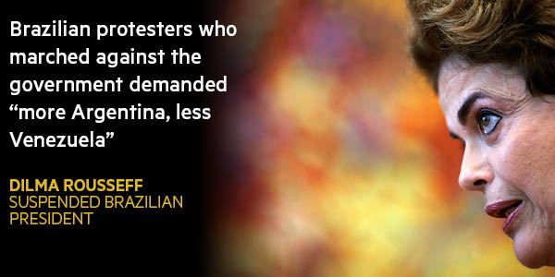
A second factor driving Latin America’s apparent sea-change is popular rage over public malfeasance — especially under leftist governments that supposedly championed the rights of the poor. Just as the 2008 financial crisis stoked voter anger in the US and Europe, so too in Latin America have tough economic times fired popular anger over the state-sanctioned corruption that took place in the boom years.
“Intolerance over corruption only happens in times of economic necessity,” says Elisa Carrió, a member of Mr Macri’s governing coalition. “Still, investigations are now being carried out in real time. That is a cultural change.”
The examples are legion, from politically compromising corruption scandals in Chile, Guatemala and Bolivia; to Petrobras’ $3bn kickback scheme that has led to the arrest of senior lawmakers across Brazil’s political spectrum; or the bizarre case of José López, a former head of Argentine public works, arrested last week while trying to bury $9m under cover of night in a convent.
A return to orthodoxy
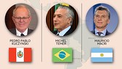
Pedro Pablo Kuczynski
Peru’s 77-year-old president-elect embodies the elite. Son of a Polish-German doctor, he went to Oxford and Princeton and is a cousin of Jean-Luc Godard. “PPK” has worked as a banker and a World Bank economist. Read more
Michel Temer
The interim president is a constitutional lawyer. Formerly vice-president, his Brazilian Democratic Movement party (PMDB) is known for pork-barrel politics. A congressman since 1987, he has been implicated in corruption scandals. Read more
Mauricio Macri
Macri, 57, found his political calling aged 32 after rogue police officers kidnapped him. His 12-year presidency of Boca Juniors football club became a Harvard case study after he rescued it from bankruptcy.Read more
“The political hegemony of [Ms Fernandez and Mr Kirchner] has ended . . . with a sudden knockout punch,” says Joaquín Morales Solá, an Argentine columnist, of the episode. “Nothing in the country will be as it was.”

In search of a vision
If nothing will be the same, though, how might Latin America’s future be different? One pessimistic answer is: perhaps not so different at all. Populism — telling voters what they want to hear, even if those promises, such as Donald Trump’s pledge to US voters to build a wall on the Mexican border, are unrealisable — can always find fertile ground, especially in countries with gaping social inequality.
What may have ended is the “super populism” of Venezuela and Ms Fernández’s Argentina. Instead, the continent may simply return to the “normal populism” that has characterised much of its history, says Moisés Naím of the Carnegie Endowment for International Peace.
Nor are Latin Americans necessarily making a permanent swing away from a discredited populist left. “Needed economic corrections that the new governments will have to make will be unpopular and create opportunities for the left to return,” adds Mr Naím.
Adding to the complexities are the 55m Latin Americans who rose into the middle class over the past decade. They have high expectations of continued advancement, making governing harder still. Is there any way to square the circle?
The easy answer is to keep spending — as Mr Macri is in Argentina. Despite raising subsidised electricity prices by 400 per cent earlier this year, a move that provoked critics to decry his administration as “brutally neoliberal”, his government has maintained social programmes and relaxed an earlier austerity drive. As a result, the fiscal deficit is expected to hit 5 per cent of gross domestic product this year.
“Mr Macri’s strategy is not risk-free,” warns Ignacio Labaqui of Medley Global Advisors, a risk consultancy. “But as long as the market is willing to back Macri with debt financing, [as is] the case so far, those deficit figures should not be a problem.”
Mr Macri is a somewhat special case, however. Like the governments of Chile, Colombia or Peru, his administration has sufficient credibility to raise funds relatively cheaply.
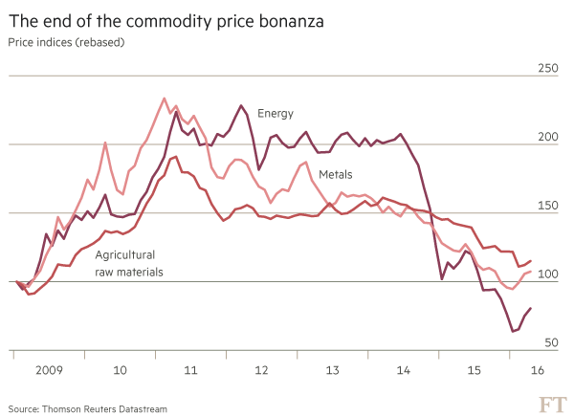
That is not true for Venezuela, which is tottering on the brink of default. Nor is it currently possible in countries such as Brazil, which spent the proceeds of the commodity bonanza and now face squeezed budgets.
In such cases, the only way to pour a litre of spending out of a pint pot of government money is through better management and public governance — that elusive grail which is “a bit about individuals and a lot about institutions”, as Mauricio Cárdenas, Colombia’s finance minister, puts it.
Social services are a case in point. That is especially so for the improvement in public education that Latin America desperately needs to develop new economy skills now the commodity boom is over.
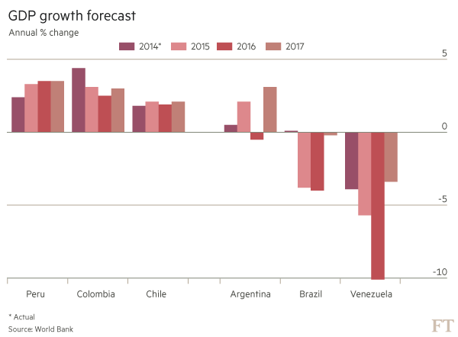
“The problem is not money,” says Ricardo Paes de Barros, who helped design Brazil’s much-lauded social welfare scheme, Bolsa Família, and is chief economist at São Paulo’s Ayrton Senna Institute and professor at Insper, a university. “Spending is the only educational goal Brazil ever hits. Rather it is a problem of governance.”

Pressure on institutions
For all its apparent blandness, a widespread and often angry call for better governance well describes Latin America’s political mood. From Argentina to Mexico, its popularity is explained by citizens weary of a sustained erosion of institutional checks and balances, and the corruption that accompanies it.
It explains the popularity of Brazil’s anti-corruption purge, led by an independent judiciary that has seen once untouchable figures, such as billionaire businessman Marcelo Odebrecht, sent to jail. It highlights the recent furore in Colombia, where a bill to punish absenteeism in Congress failed after not enough politicians turned up to vote.
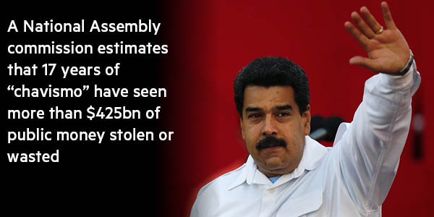
Calls for better governance may even encourage political change in Venezuela. In another sign of the region’s shifting politics, the Organisation of American States meets on Thursday to discuss sanctioning Venezuela for human rights abuses. The debate would have been unimaginable a year ago.
If better governance is the way forward, though, that generates its own problems. For one, “reasonableness” and “institutionalism” are not slogans that make political pulses race. In Chile, the centre-right government of Sebastián Piñera won power in 2010 with the slogan “we are good managers”, and spent four years with 30 per cent approval ratings despite a booming economy and low unemployment.
“Good management is a necessary but not a sufficient condition,” says Andrés Velasco, a former Chilean finance minister. “Voters today not only need to feel that leaders are managing well, they also need to feel that their heart is in the right place, and that they are acting on behalf of the common good.”
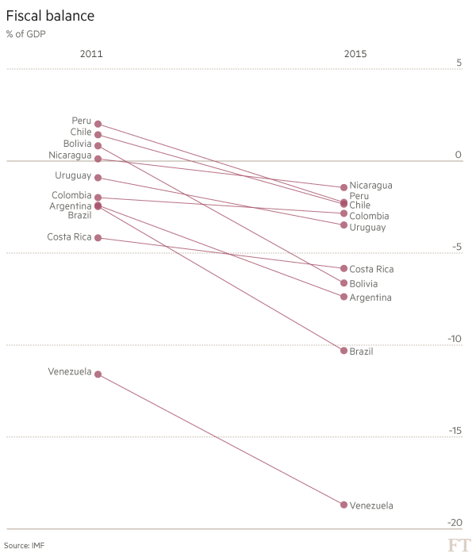
That is as true of Latin America, with its traditions of populism, as it is elsewhere — be that in Britain or the US, where the campaign to leave the EU and Mr Trump’s political rise are often explained in terms of voter emotions, rather than reason.
“Populism generates a certain anaesthesia. It’s a social pathology, where people prefer to live a false reality,” says Ms Michetti. “That anaesthesia is lifting in Argentina, but we still need an epic narrative . . . a vision.”
Latin America’s latest generation of leaders are yet to find it.
Additional reporting by Andres Schipani
Mexico: Political tensions rise as anti-graft laws diluted
When Mexico’s Congress last week passed legislation to implement anti-corruption reforms, President Enrique Peña Nieto was among the first to applaud. It was, he tweeted, the dawning of a new era of “honesty, transparency and accountability in public service”.
If only that were true. His own Institutional Revolutionary party (PRI) helped water down the legislation and with it any real drive to stamp out corruption, which polls show is a major voter concern. Clauses were rewritten, granting public servants discretion over publishing details of their tax, income and conflict of interest declarations. Legislators extended that so-called “three-for-three” requirement to companies or individuals doing business with the government — a move seen as an attempt to torpedo measures to single out politicians for scrutiny. As Mr Peña Nieto ponders whether to use his presidential veto to toughen the laws, he has come under fire from his own party.
“We are obliged to hear the voice and the demands of citizens, both PRI voters and those of other parties, who demand better results from their governments and a fight against corruption and impunity, wherever they may be,” Manlio Fabio Beltrones said in a stinging resignation speech as PRI chairman this week. His exit followed the party’s drubbing by the conservative National Action party (PAN) in gubernatorial elections earlier in June. The PRI won just five of the 12 states up for grabs.
With presidential elections in 2018, the PRI looks vulnerable to a resurgent PAN but also firebrand leftistAndrés Manuel López Obrador, a former candidate who is topping early polls. Mr Peña Nieto talks about zero tolerance for corruption but voters fed up with broken promises could punish any failure to deliver. Jude Webber

